Nationwide Academic Institution Profile Search Program

Carol Zhang zhangw11@miamioh.edu

STA402 Statistical Programming Dr. Stephen Wright Miami University

Project Introduction

For graduating high school or college students, people from the workforce seeking to go back to school for further academic development, parents and agencies collecting school information for comprehensive consideration, the process of obtaining objective institutional information of colleges and universities in order to discover and explore desired programs/institutions can be difficult and time-consuming. Utilizing a database file containing authentic classification and detailed institutional profile of US nationwide academic institutions, this SAS program enables users to input minimal searching key words or criteria and receive professional and informative output tables providing standardized search results and relevant/similar institution recommendations. This program aims to assist individuals and organizations to kick start their school search in an early stage and to provide authentic school classification and institutional information that are difficult to obtain and being collected all together in a comparative form otherwise.

This program is designed primarily to assist users in academic institution search in the following ways:

1. Obtain institution profile and detailed institutional information/classifications by searching for institution name.
2. Obtain profile and information of institutions in a particular city, state, or geographic region.
3. Obtain profile and information of institutions in specialized field/category, for example, Minority Serving Institutions, Women’s College, Historically Black Colleges and Universities, etc.
4. Obtain profile and information of institutions in the same academic classification, for example, Medical Schools, Business Schools, Art/Music/Design Schools, etc.
5. Obtain informative and collective tables of institutions of interest or searched. Comparison across different categories made easy.

Description of Data

Data used in this project come from Carnegie Foundation for the Advancement of Teaching, Carnegie Classifications Data File, February, 2012. Data is stored in an xls file with four sheets: ReadMe, Variables, Labels, and Data. 84 variables are available and listed. Major variables used in this project include NAME (Institution Name), CC2000 (Carnegie Classification of Institutions), CCSIZSET (Size and Setting Classification), CITY (City location of institution), ENRPROFILE2010 (Enrollment Profile Classification), MSI (Minority Serving Institution), etc.

Labels sheet contains label information for each variable, here are three of the variables we are using in this program—Geographic Region, Control of Institution:

|  |  |  |
| --- | --- | --- |
| obereg Geographic Region | 0 | US Service schools |
|  | 1 | New England CT ME MA NH RI VT |
|  | 2 | Mid East DE DC MD NJ NY PA |
|  | 3 | Great Lakes IL IN MI OH WI |
|  | 4 | Plains IA KS MN MO NE ND SD |
|  | 5 | Southeast AL AR FL GA KY LA MS NC SC TN VA WV |
|  | 6 | Southwest AZ NM OK TX |
|  | 7 | Rocky Mountains CO ID MT UT WY |
|  | 8 | Far West AK CA HI NV OR WA |
|  | 9 | Outlying areas AS FM GU MH MP PR PW VI |

|  |  |  |
| --- | --- | --- |
| control Control of Institution | 1 | Public |
|  | 2 | Private not-for-profit |
|  | 3 | Private for-profit |

Data sheet contains a table of all variables and their values for each national institution listed. For example, for Miami University in Oxford, part of the row looks like:

|  |  |  |  |  |  |  |
| --- | --- | --- | --- | --- | --- | --- |
| NAME | CITY | STABBR | IPUG2010 | ENRPROFILE2010 | SIZESET2010 | CCBASIC |
| Miami University Oxford | Oxford | OH | 10 | 3 | 17 | 16 |

In the data sheet there are 4634 observations in total. In other words, 4634 distinct US academic institutions are listed in this database file.

Methods

Using PROC IMPORT, the SAS program reads in all data from the xls file as the fundamental data for all query and search functions performed in the macro “createtables”.

Within a pop up window, a user can input search phrases and key words, specify how many search results they want to see, choose to provide a directory path for pdf generation or not, and then submit all search criteria into the program by pressing Enter in the end. These criteria will then be passed into the macro function to create result tables. %WINDOW and %DISPLAY SAS statements are used to create and display the input window to users.

All characters and numeric values the user types into the search interface will be used directly in the data search. Therefore, a typo, missing letters/spaces, non-matching information or incorrect capitalization may result at no return of search results. When no results are generated, no table or pdf file will be created. Remedy for this problem is to provide the option to view an all institution table which has all the full names of the institutions in the database. If desired, a user may simply execute PROC PRINT and take a look at the all names table or do a look-up for the name wanted. This primarily addresses the problem when a user isn’t sure about the spelling of the full name or simply wants know the name that’s recorded in this database (after a few attempts but have no search results returned). Again, users may execute the corresponding PROC PRINT to view all schools names and do a “Find” search to get the accurate name of an institution.

The program will then perform multiple PROC SQL procedures on the inputs and produce a main search result table and either one, two, or three recommendation table(s). Tables are produced primarily using “SELECT” and “WHERE” SQL statements. Within “WHERE” statements, macro controls %IF and %THEN, %DO and %END are used to make sure all the non-empty input values are used to generate search results and unspecified variables will be omitted in the selection process. For example, the code for the city variable looks like %if &CITY ^= %then %do; CITY = "&&CITY" and %end;, therefore only in the case of a city value is entered, the city value is used in searching. In the last line of the “WHERE” statement, number 1 is used to end the “AND” conditions: %if &TRIBAL ^= %then %do; TRIBAL = &&TRIBAL and %end; **1**;. PROC PRINT procedures are used to print out all tables.

The main search result table contains selected information of each institutions found, displayed variables include: NAME, CITY, STATE, CC2000, IPUG2010, IPGRAD2010, ENRPROFILE2010, SIZESET2010, UGPROFILE2010, CONTROL, LOCALE, HBCU, TRIBAL, HSI, MSI, WOMENS, etc. For each numeric variable, a PROC FORMAT formatting is created beforehand for meaningful information output to the user.

The first recommendation table will provide information of institutions in the same city with the searched institution(s), if variables “Name” and “CITY” are both specified inputs. Institutions with the most matching criteria, based on user input, are chosen to be displayed. For example if a user entered “New York University” as NAME, “New York” as CITY, and “1-Public” as CONTROL, leaving all other variables blank, the first recommendation table will provide information of all other public schools in New York city. If a user didn’t specify a City to search for, this table will not be generated or displayed.

The second recommendation table will provide information of institutions in the same state with the searched institution(s), if variables “Name” and “STATE” are specified inputs. Institutions with the most matching criteria, based on user input, are chosen to be displayed. The result generation for this table works the same way as the city table. If a user didn’t input a State to search for, this table will not be generated or displayed.

The third recommendation table will provide information of institutions when a user inputs a “1” (Yes) for any of the following variables: WOMENS, HSI, MSI, HBCU, and TRIBAL. Institutions fall into these categories will have their detailed information displayed in this recommendation table. If a user didn’t input any value to these variables or entered “0” (“No”) for them, this table will not be generated or displayed. For example if a “1” is entered for WOMENS and “MA” is entered for State, this recommendation table will provide a list of Women’s Colleges located in all states, whereas the main search result table will return Women’s Colleges in Massachusetts.

At the end of the program a PROC DATASETS is used to delete all tables created by PROC SQL.

Demonstration and Result

In this section there are four demonstrations of how users can use this SAS program to obtain different search results. Once the program is executed, a user encounters the input window and may starts to enter search criteria (Capture 0):

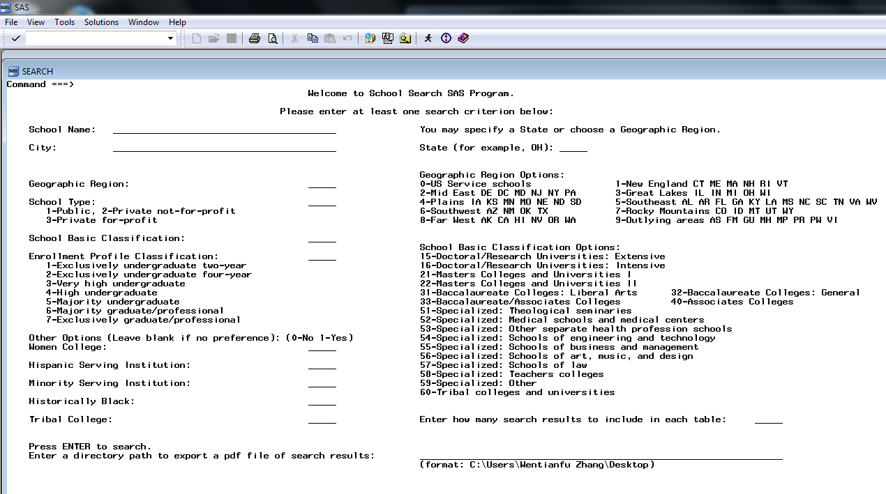

Capture 0

As shown in Capture 0, this interface contains input lines for school name, city, state abbreviation, options for geographical region, school type, enrollment profile classification, school basic classification, and five optional yes-or-no boxes for specialty schools. A user may also specify how many search results to display in each table (this only applies towards the recommendation tables). If no value is entered for results display, the default number of rows in a recommendation table is 10. At the end, a user can enter a directory path for exporting search results to a pdf file. An example of directory path format is given right below the input line. Once “Enter” is pressed, this input window will disappear and pass all values to perform the macro function.

### Demo 1 (Harvard University + MA + Max 10 results+ directory path):

Suppose in the input window a user entered “Harvard University”, “MA”, 10 for maximum results, and a directory path (Capture1-1):

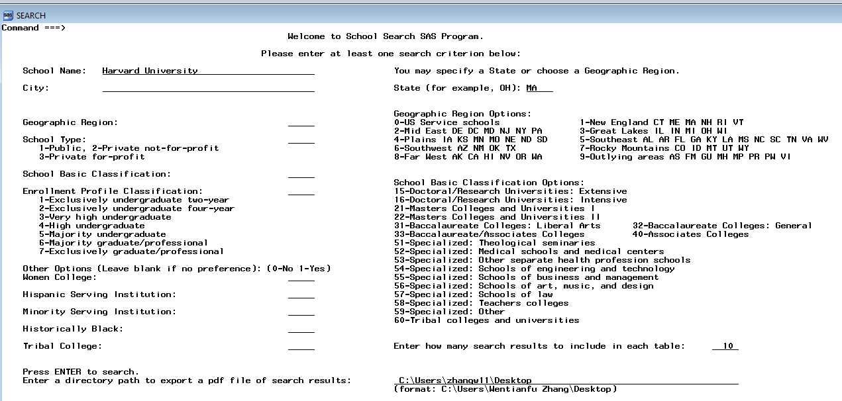

Capture1-1

The inputs are being written into the log for the record (Capture1-2):

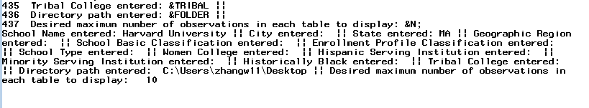

Capture1-2

Once the table generation macro is executed, the following results are printed in the result window (Capture1-3): The first table “Your Search Result” is the main table containing the detailed institutional information of Harvard University, and the second table “More Schools in MA” has the detailed information of 10 other schools in MA (Massachusetts) ordered in alphabetically order since no other variable is specified.

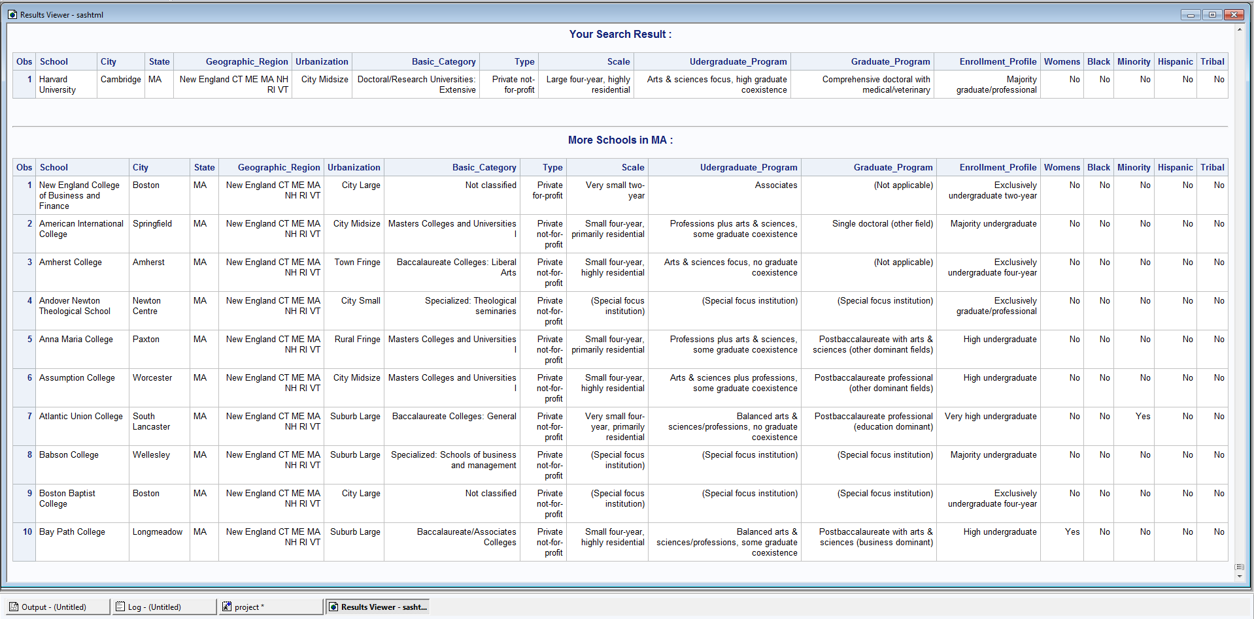

Capture1-3

At the same time, a “SearchResultsHarvardUniversityMA” pdf file containing both tables is generated on the desktop (Capture1-4 and Capture1-5):

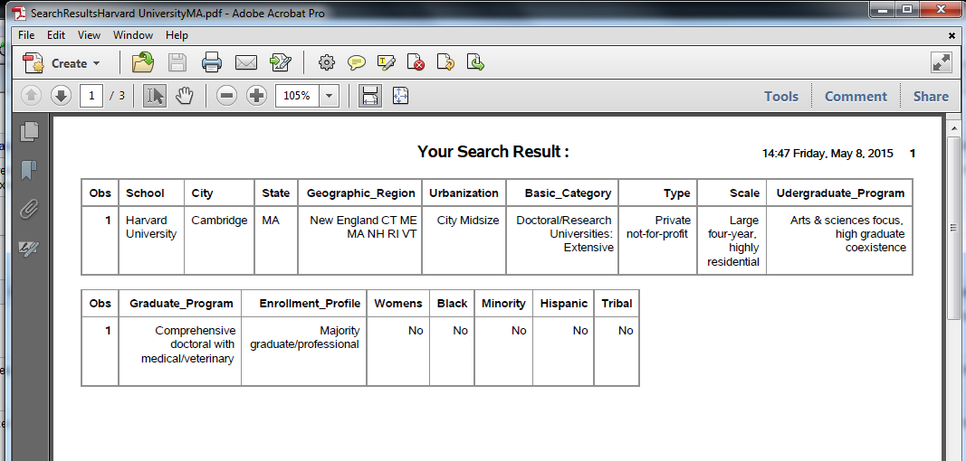

Capture1-4

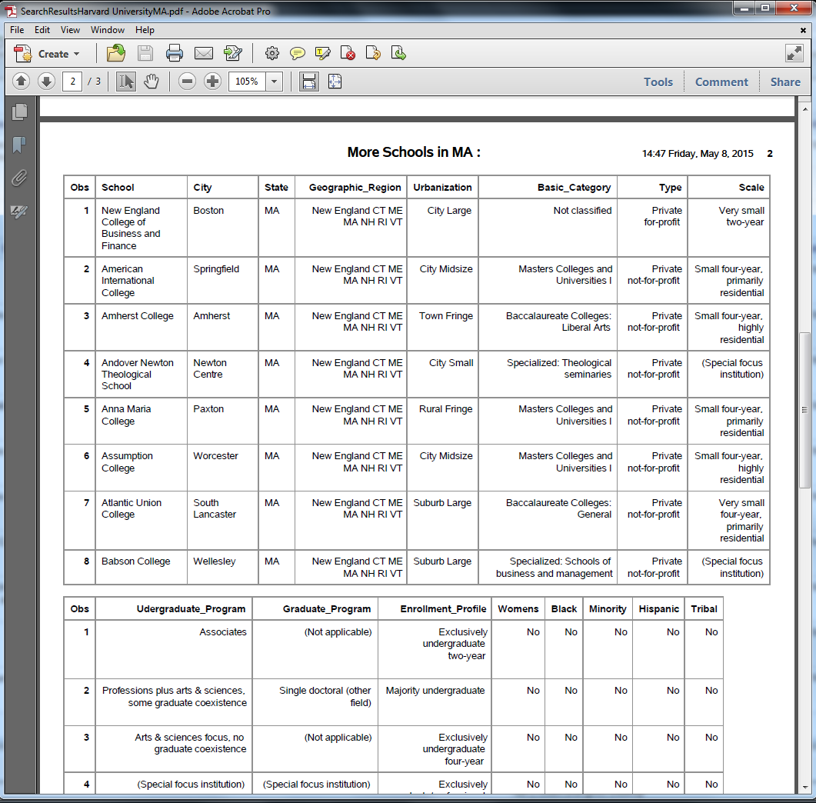

Capture1-5

End of Demo 1.

### Demo 2 (City + School Basic Classification + Enrollment Profile + no path):

In this demo, city and two filtering variables are specified. Entering 0s to all five “other options” will filter out all specialty schools from the search result. A directory path is not entered, so no pdf file will be generated.

In the input window “Cambridge” is entered as City and we’re searching for highly competitive doctoral and research with emphasis on graduate programs (Capture2-1). Maximum 8 is entered for results display even if it doesn’t affect the outcome in this particular case:

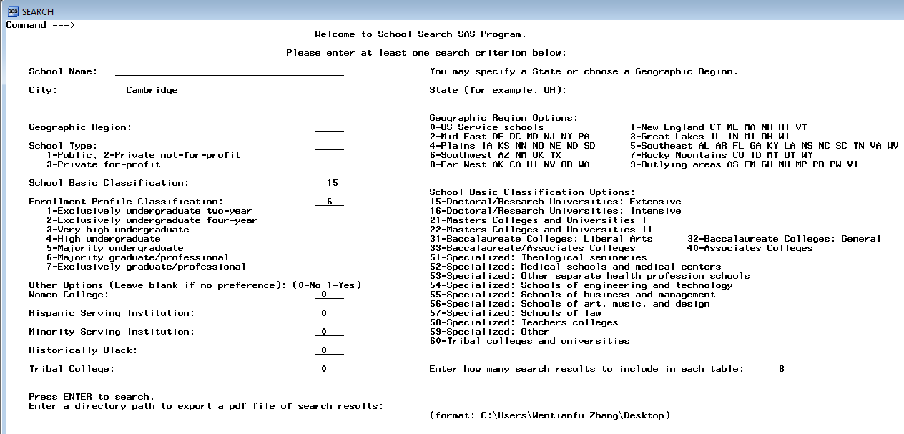

Capture2-1

Take a look at the log record, values were entered correctly (Capture2-2):

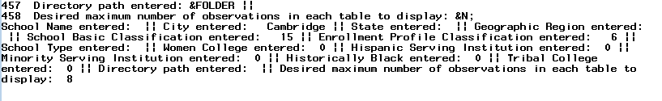

Capture2-2

Search result is generated correctly (Capture2-3), Harvard University and MIT are returned:



Capture2-3

End of Demo 2.

Demo 3 (MIT + City + no path):

In this demo let’s suppose the user doesn’t know the full name of MIT and has to find out by opening up all school names table to look it up (Capture3-0):

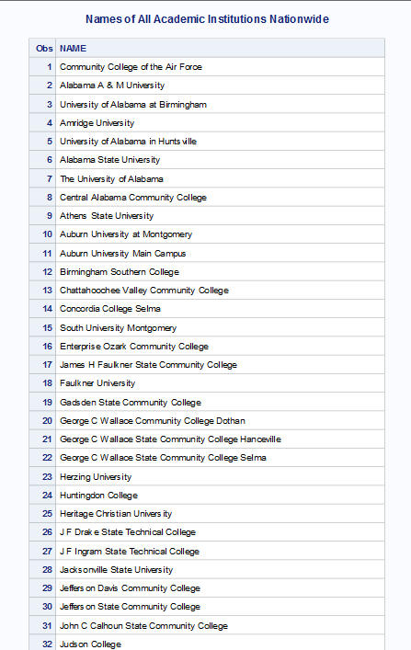

…

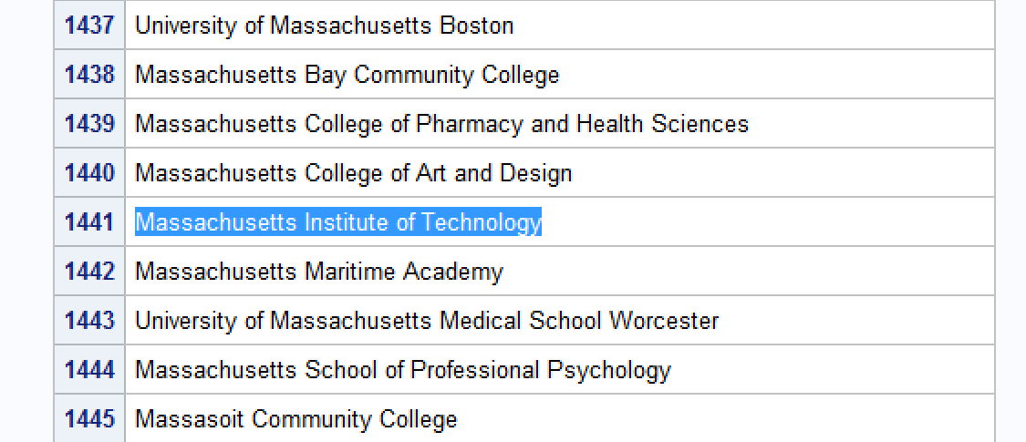

Capture3-0

Then the user enters the full name, city name—Cambridge, and maximum 5 for result display (Capture3-1):

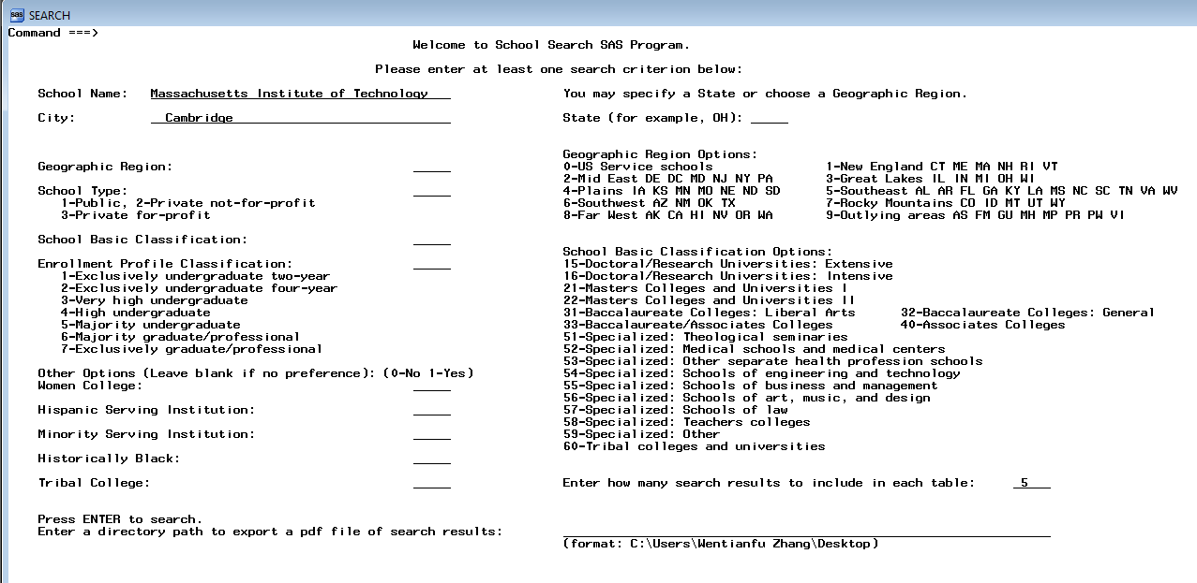

Capture3-1

Two tables are generated as a result: the main one—Massachusetts Institute of Technology, and the recommendation table with 5 other institutions in Cambridge (Capture3-2):

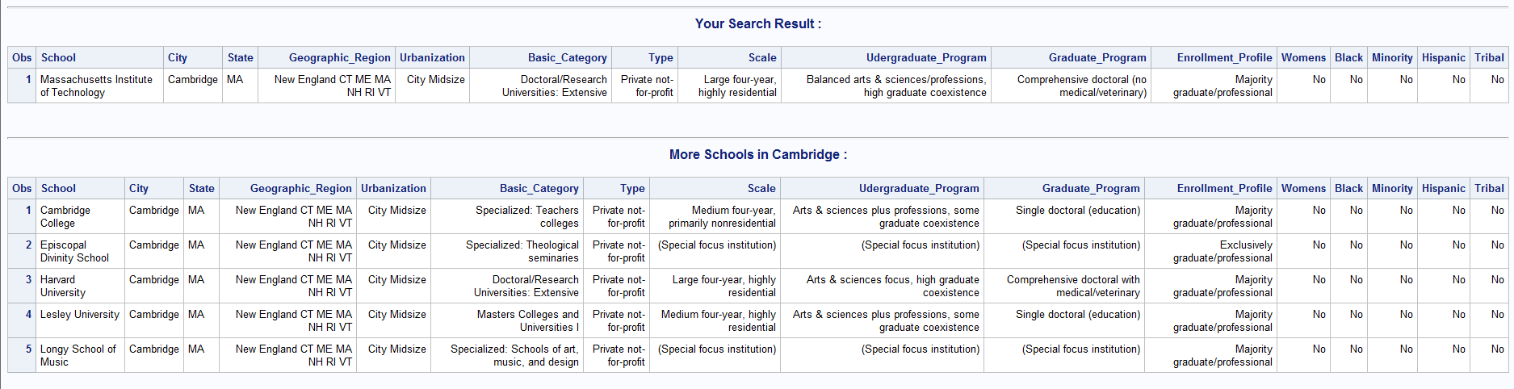

Capture3-2

End of Demo 3.

Demo 4 (Minority Serving Institution + New England region + Not Historically Black College and University + Not Women’s College + no path + max results 7):

This demo is for a user who’s searching for minority serving institutions in the New English region, that are either historically black colleges/universities, or women’s colleges. No directory path is entered and maximum result display is entered to be 7 (Capture4-1): (please note that variables “Hispanic Serving Institution” and “Tribal College” are left blank instead of indicated to be “No”, so such schools can still be selected)

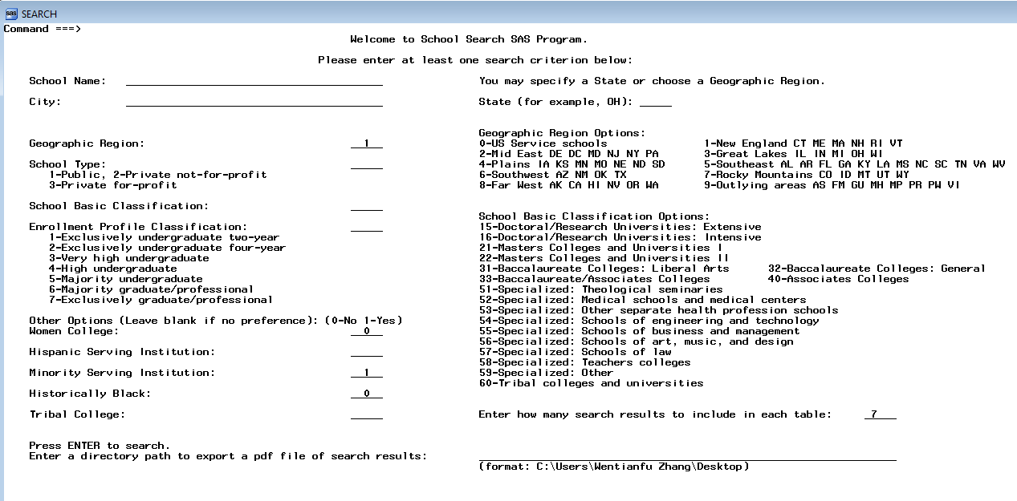

Capture4-1

Take a look at the log record (Capture4-2):

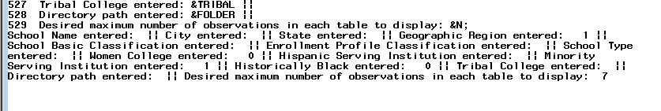

Capture4-2

Search results: 4 colleges qualify the search criteria and are included in the main search result table. The recommendation table contains information for 7 institutions that qualify but are not necessarily in the New English region (Capture4-3):

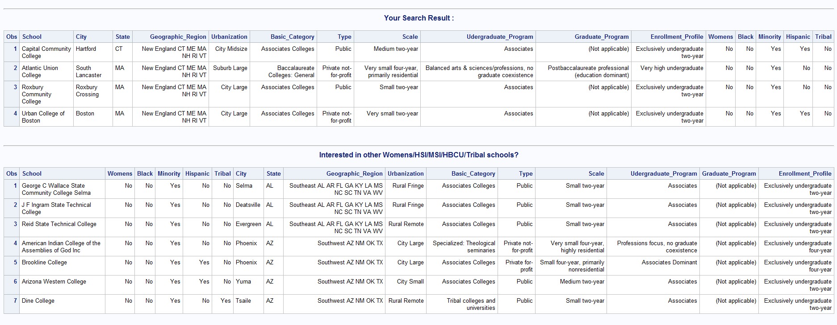

Capture4-3

End of Demo 4.

Discussion

There are 16 selected variables being displayed in the search result. Three basic, non-numeric, items: Name, City, and State Abbreviation. Five categorical, numeric items: Geographic Region (OBEREG), Basic School Category (CC2000), Undergraduate Program (IPUG2010), Graduate Program (IPGRAD2010), and Enrollment Profile (ENRPROFILE2010). Three factual, numeric items: Scale (Size and Setting—SIZESET2010), Control of Institution (CONTROL), and Degree of Urbanization (LOCALE). Five specialty institution options: Historically Black College or University (HBCU), Tribal College (TRIBAL), Women's College (WOMENS), Hispanic Serving Institution (HIS), and Minority Serving Institution (MSI).

These 16 items of institutional information are selected based on their relevance, importance, and ranking of interest. According to the feedback from a small sample of student users, qualitative information such as Undergraduate & Graduate Program, Geographic Region, Enrollment Profile, and Degree of Urbanization appear to be the most eyeball-catching pieces of information that people look at when they compare qualities of multiple institutions. A few searchable items from the original database are eliminated due to unpopularity and redundancy, such as “Medical Schools” option. The selected 16 finales are tailored to provide users meaning and useful search results to guide them into more in-depth research of certain academic institutions they are interested at. This program also offers pre-filtering functionality to help narrowing down candidates: a user may do so by specifying Control of Institution (public or private, for-profit or non-profit), Enrollment Profile, Scale (Size and Setting), Degree of Urbanization, etc.

This program is particularly helpful when the user is looking to compare institutions in a certain city, state, region, a certain type, specialty, or to compare institutions with similar Basic School Category, Undergraduate or Graduate Program. For people who are looking for Women’s College, Minority/Hispanic/Black Serving Institution, or Tribal College, this program does particularly well in providing lists of qualifying schools inside and outside of the region of interest, and at the same time, offering all other important information of such schools.

There are some outstanding issues of this program. User input inaccuracy creates program faults: If a user enters character values into a numeric variable’s blank space (vice versa), values passed into PROC SQL won’t match up with the data, no results will be generated. This SAS program doesn’t equip an input type check and alert function. The program also doesn’t include a conflicting input check and alert, in the case if a user enters “Miami University Oxford” and “KY” as State – non-matching information—therefore no search result will be generated. If a user enters no value at all into any blank but specifies a pdf directory path, a pdf file of all the institutions’ profiles will be generated. In another word, a user may obtain the entire database in a pdf file from this SAS program.

References

1. Carnegie Foundation for the Advancement of Teaching, Carnegie Classifications Data File, February, 2012.
2. Jeff Abolafia, “What Would I Do without Proc Sql and the Macro Language”, SAS Institute Inc. (1997), SAS Macro Language Reference, First Edition, Cary, NC: SAS Institute Inc., Paper 031-30.
3. Kenneth W. Borowiak, “Using Data Set Options in PROC SQL”, Howard M. Proskin & Associates, Inc. Rochester, NY, Paper 131-31.
4. “Using PROC SQL with the SAS Macro Facility”, SAS(R) 9.2 SQL Procedure User's Guide, SAS Support, http://support.sas.com/documentation/cdl/en/sqlproc/62086/HTML/default/viewer.htm#a001360983.htm.

## Appendices

All SAS code:

************************************import data;

**PROC** **IMPORT** OUT= WORK.projectdata DATAFILE= "C:\Users\Wentianfu Zhang\Desktop\STA402-SAS\TermProject\AcademicInstitutionsProfileNationwide.xls"

DBMS=xls;

SHEET="Data";

GETNAMES=YES;

**RUN**;

************************************create all formats;

**proc** **format**;

value womens

**0**='No'

**1**='Yes';

**run**;

**proc** **format**;

value hsi

**0**='No'

**1**='Yes';

**run**;

**proc** **format**;

value msi

**0**='No'

**1**='Yes';

**run**;

**proc** **format**;

value hbcu

**0**='No'

**1**='Yes';

**run**;

**proc** **format**;

value tribal

**0**='No'

**1**='Yes';

**run**;

**proc** **format**;

value obereg

**0**='US Service schools'

**1**='New England CT ME MA NH RI VT'

**2**='Mid East DE DC MD NJ NY PA'

**3**='Great Lakes IL IN MI OH WI'

**4**='Plains IA KS MN MO NE ND SD'

**5**='Southeast AL AR FL GA KY LA MS NC SC TN VA WV'

**6**='Southwest AZ NM OK TX'

**7**='Rocky Mountains CO ID MT UT WY'

**8**='Far West AK CA HI NV OR WA'

**9**='Outlying areas AS FM GU MH MP PR PW VI';

**run**;

**proc** **format**;

value control

**1**='Public'

**2**='Private not-for-profit'

**3**='Private for-profit';

**run**;

**proc** **format**;

value cc

-**3**='Not classified'

**15**='Doctoral/Research Universities: Extensive'

**16**='Doctoral/Research Universities: Intensive'

**21**='Masters Colleges and Universities I'

**22**='Masters Colleges and Universities II'

**31**='Baccalaureate Colleges: Liberal Arts'

**32**='Baccalaureate Colleges: General'

**33**='Baccalaureate/Associates Colleges'

**40**='Associates Colleges'

**51**='Specialized: Theological seminaries'

**52**='Specialized: Medical schools and medical centers'

**53**='Specialized: Other separate health profession schools'

**54**='Specialized: Schools of engineering and technology'

**55**='Specialized: Schools of business and management'

**56**='Specialized: Schools of art, music, and design'

**57**='Specialized: Schools of law'

**58**='Specialized: Teachers colleges'

**59**='Specialized: Other'

**60**='Tribal colleges and universities';

**run**;

**proc** **format**;

value enrprofile

**1**='Exclusively undergraduate two-year'

**2**='Exclusively undergraduate four-year'

**3**='Very high undergraduate'

**4**='High undergraduate'

**5**='Majority undergraduate'

**6**='Majority graduate/professional'

**7**='Exclusively graduate/professional';

**run**;

**proc** **format**;

value ipug

-**2**='(Special focus institution)'

-**1**='(Not applicable)'

**0**='(Not classified)'

**1**='Associates'

**2**='Associates Dominant'

**3**='Arts & sciences focus, no graduate coexistence'

**4**='Arts & sciences focus, some graduate coexistence'

**5**='Arts & sciences focus, high graduate coexistence'

**6**='Arts & sciences plus professions, no graduate coexistence'

**7**='Arts & sciences plus professions, some graduate coexistence'

**8**='Arts & sciences plus professions, high graduate coexistence'

**9**='Balanced arts & sciences/professions, no graduate coexistence'

**10**='Balanced arts & sciences/professions, some graduate coexistence'

**11**= 'Balanced arts & sciences/professions, high graduate coexistence'

**12**= 'Professions plus arts & sciences, no graduate coexistence'

**13**= 'Professions plus arts & sciences, some graduate coexistence'

**14**= 'Professions plus arts & sciences, high graduate coexistence'

**15**= 'Professions focus, no graduate coexistence'

**16**= 'Professions focus, some graduate coexistence'

**17**= 'Professions focus, high graduate coexistence';

**run**;

**proc** **format**;

value ipgrad

-**2**='(Special focus institution)'

-**1**='(Not applicable)'

**0**='(Not classified)'

**1**='Single postbaccalaureate (education)'

**2**='Single postbaccalaureate (business)'

**3**='Single postbaccalaureate (other field)'

**4**='Postbaccalaureate comprehensive'

**5**='Postbaccalaureate, arts & sciences dominant'

**6**='Postbaccalaureate with arts & sciences (education dominant)'

**7**='Postbaccalaureate with arts & sciences (business dominant)'

**8**='Postbaccalaureate with arts & sciences (other dominant fields)'

**9**='Postbaccalaureate professional (education dominant)'

**10**='Postbaccalaureate professional (business dominant)'

**11**='Postbaccalaureate professional (other dominant fields)'

**12**='Single doctoral (education)'

**13**='Single doctoral (other field)'

**14**='Comprehensive doctoral with medical/veterinary'

**15**='Comprehensive doctoral (no medical/veterinary)'

**16**='Doctoral, humanities/social sciences dominant'

**17**='Doctoral, STEM dominant'

**18**='Doctoral, professional dominant';

**run**;

**proc** **format**;

value sizeset

-**2**='(Special focus institution)'

-**1**='(Not applicable)'

**0**='(Not classified)'

**1**='Very small two-year'

**2**='Small two-year'

**3**='Medium two-year'

**4**='Large two-year'

**5**='Very large two-year'

**6**='Very small four-year, primarily nonresidential'

**7**='Very small four-year, primarily residential'

**8**='Very small four-year, highly residential'

**9**='Small four-year, primarily nonresidential'

**10**='Small four-year, primarily residential'

**11**='Small four-year, highly residential'

**12**='Medium four-year, primarily nonresidential'

**13**='Medium four-year, primarily residential'

**14**='Medium four-year, highly residential'

**15**='Large four-year, primarily nonresidential'

**16**='Large four-year, primarily residential'

**17**='Large four-year, highly residential'

**18**='Exclusively graduate/professional';

**run**;

**proc** **format**;

value locale

-**3**='{Not available}'

**11**='City Large'

**12**='City Midsize'

**13**= 'City Small'

**21**= 'Suburb Large'

**22**= 'Suburb Midsize'

**23**= 'Suburb Small'

**31**= 'Town Fringe'

**32**= 'Town Distant'

**33**= 'Town Remote'

**41**= 'Rural Fringe'

**42**= 'Rural Distant'

**43**= 'Rural Remote'

;

**run**;

******************************create user input window;

%window search color=white

#**1** @**55** 'Welcome to School Search SAS Program.' attr=highlight

#**3** @**50** 'Please enter at least one search criterion below:'

#**5** @**5** 'School Name:'

#**5** @**20** NAME **40** attr=underline

#**5** @**75** 'You may specify a State or choose a Geographic Region.'

#**7** @**5** 'City:'

#**7** @**20** CITY **40** attr=underline

#**7** @**75** 'State (for example, OH):'

#**7** @**100** STATE **5** attr=underline

#**11** @**5** 'Geographic Region:'

#**11** @**55** OBEREG **5** attr=underline

#**10** @**75** 'Geographic Region Options:'

#**11** @**75** '0-US Service schools'

#**11** @**110** '1-New England CT ME MA NH RI VT'

#**12** @**75** '2-Mid East DE DC MD NJ NY PA'

#**12** @**110** '3-Great Lakes IL IN MI OH WI'

#**13** @**75** '4-Plains IA KS MN MO NE ND SD'

#**13** @**110** '5-Southeast AL AR FL GA KY LA MS NC SC TN VA WV'

#**14** @**75** '6-Southwest AZ NM OK TX'

#**14** @**110** '7-Rocky Mountains CO ID MT UT WY'

#**15** @**75** '8-Far West AK CA HI NV OR WA'

#**15** @**110** '9-Outlying areas AS FM GU MH MP PR PW VI'

#**13** @**5** 'School Type:'

#**13** @**55** CONTROL **5** attr=underline

#**14** @**8** '1-Public, 2-Private not-for-profit'

#**15** @**8** '3-Private for-profit'

#**17** @**5** 'School Basic Classification:'

#**17** @**55** CC2000 **5** attr=underline

#**18** @**75** 'School Basic Classification Options: '

#**19** @**75** '15-Doctoral/Research Universities: Extensive'

#**20** @**75** '16-Doctoral/Research Universities: Intensive'

#**21** @**75** '21-Masters Colleges and Universities I'

#**22** @**75** '22-Masters Colleges and Universities II'

#**23** @**75** '31-Baccalaureate Colleges: Liberal Arts'

#**23** @**120** '32-Baccalaureate Colleges: General'

#**24** @**75** '33-Baccalaureate/Associates Colleges'

#**24** @**120** '40-Associates Colleges'

#**25** @**75** '51-Specialized: Theological seminaries'

#**26** @**75** '52-Specialized: Medical schools and medical centers'

#**27** @**75** '53-Specialized: Other separate health profession schools'

#**28** @**75** '54-Specialized: Schools of engineering and technology'

#**29** @**75** '55-Specialized: Schools of business and management'

#**30** @**75** '56-Specialized: Schools of art, music, and design'

#**31** @**75** '57-Specialized: Schools of law'

#**32** @**75** '58-Specialized: Teachers colleges'

#**33** @**75** '59-Specialized: Other'

#**34** @**75** '60-Tribal colleges and universities'

#**19** @**5** 'Enrollment Profile Classification:'

#**19** @**55** ENRPROFILE2010 **5** attr=underline

#**20** @**8** '1-Exclusively undergraduate two-year'

#**21** @**8** '2-Exclusively undergraduate four-year'

#**22** @**8** '3-Very high undergraduate'

#**23** @**8** '4-High undergraduate'

#**24** @**8** '5-Majority undergraduate'

#**25** @**8** '6-Majority graduate/professional'

#**26** @**8** '7-Exclusively graduate/professional'

#**28** @**5** 'Other Options (Leave blank if no preference):'

#**28** @**51** '(0-No 1-Yes)'

#**29** @**5** 'Women College:'

#**29** @**55** WOMENS **5** attr=underline

#**31** @**5** 'Hispanic Serving Institution:'

#**31** @**55** HSI **5** attr=underline

#**33** @**5** 'Minority Serving Institution:'

#**33** @**55** MSI **5** attr=underline

#**35** @**5** 'Historically Black:'

#**35** @**55** HBCU **5** attr=underline

#**37** @**5** 'Tribal College:'

#**37** @**55** TRIBAL **5** attr=underline

#**37** @**75** 'Enter how many search results to include in each table:'

#**37** @**135** N **5** attr=underline

#**40** @**5** 'Press ENTER to search.'

#**41** @**5** 'Enter a directory path to export a pdf file of search results:'

#**41** @**75** FOLDER **65** attr=underline

#**42** @**75** '(format: C:\Users\Wentianfu Zhang\Desktop)';

/** Macro program “createtables” to generate results in tabular form and create a pdf file containing search results saved to the location the user specifies, 14 parameters are passed in. **/

**%MACRO** createtables(NAME=, CITY=, STATE=, OBEREG=, CC2000=, ENRPROFILE2010=, CONTROL=, WOMENS=, HSI=, MSI=, HBCU=, TRIBAL=, FOLDER=, N=);

proc sql;

create table results as

select NAME as School, CITY as City, STABBR as State, OBEREG as Geographic_Region, LOCALE as Urbanization, CC2000 as Basic_Category,

CONTROL as Type, SIZESET2010 as Scale, IPUG2010 as Udergraduate_Program, IPGRAD2010 as Graduate_Program, ENRPROFILE2010 as Enrollment_Profile,

WOMENS as Womens, HBCU as Black, MSI as Minority, HSI as Hispanic, TRIBAL as Tribal from WORK.projectdata

where %if &NAME ^= %then %do; NAME contains "&&NAME" and %end;

%if &CITY ^= %then %do; CITY = "&&CITY" and %end;

%if &STATE ^= %then %do; STABBR = "&&STATE" and %end;

%if &OBEREG ^= %then %do; OBEREG = &&OBEREG and %end;

%if &CC2000 ^= %then %do; CC2000 = &&CC2000 and %end;

%if &ENRPROFILE2010 ^= %then %do; ENRPROFILE2010 = &&ENRPROFILE2010 and %end;

%if &CONTROL ^= %then %do; CONTROL = &&CONTROL and %end;

%if &WOMENS ^= %then %do; WOMENS = &&WOMENS and %end;

%if &HSI ^= %then %do; HSI = &&HSI and %end;

%if &MSI ^= %then %do; MSI = &&MSI and %end;

%if &HBCU ^= %then %do; HBCU = &&HBCU and %end;

%if &TRIBAL ^= %then %do; TRIBAL = &&TRIBAL and %end; **1**;

create table searchresults as

select * from results;

%if &CITY ^= and &NAME ^= %then %do;

create table samecityresults as

select NAME as School, CITY as City, STABBR as State, OBEREG as Geographic_Region, LOCALE as Urbanization, CC2000 as Basic_Category,

CONTROL as Type, SIZESET2010 as Scale, IPUG2010 as Udergraduate_Program, IPGRAD2010 as Graduate_Program, ENRPROFILE2010 as Enrollment_Profile,

WOMENS as Womens, HBCU as Black, MSI as Minority, HSI as Hispanic, TRIBAL as Tribal from WORK.projectdata

where %if &CITY ^= %then %do; CITY = "&&CITY" and %end;

%if &CC2000 ^= %then %do; CC2000 = &&CC2000 and %end;

%if &ENRPROFILE2010 ^= %then %do; ENRPROFILE2010 = &&ENRPROFILE2010 and %end;

%if &CONTROL ^= %then %do; CONTROL = &&CONTROL and %end;

%if &WOMENS ^= %then %do; WOMENS = &&WOMENS and %end;

%if &HSI ^= %then %do; HSI = &&HSI and %end;

%if &MSI ^= %then %do; MSI = &&MSI and %end;

%if &HBCU ^= %then %do; HBCU = &&HBCU and %end;

%if &TRIBAL ^= %then %do; TRIBAL = &&TRIBAL and %end; **1**;

%end;

%if &NAME ^= and &STATE ^= %then %do;

create table samestateresults as

select NAME as School, CITY as City, STABBR as State, OBEREG as Geographic_Region, LOCALE as Urbanization, CC2000 as Basic_Category,

CONTROL as Type, SIZESET2010 as Scale, IPUG2010 as Udergraduate_Program, IPGRAD2010 as Graduate_Program ,ENRPROFILE2010 as Enrollment_Profile,

WOMENS as Womens, HBCU as Black, MSI as Minority, HSI as Hispanic, TRIBAL as Tribal from WORK.projectdata

where %if &STATE ^= %then %do; STABBR = "&&STATE" and %end;

%if &CC2000 ^= %then %do; CC2000 = &&CC2000 and %end;

%if &ENRPROFILE2010 ^= %then %do; ENRPROFILE2010 = &&ENRPROFILE2010 and %end;

%if &CONTROL ^= %then %do; CONTROL = &&CONTROL and %end;

%if &WOMENS ^= %then %do; WOMENS = &&WOMENS and %end;

%if &HSI ^= %then %do; HSI = &&HSI and %end;

%if &MSI ^= %then %do; MSI = &&MSI and %end;

%if &HBCU ^= %then %do; HBCU = &&HBCU and %end;

%if &TRIBAL ^= %then %do; TRIBAL = &&TRIBAL and %end; **1**;

%end;

%if &WOMENS=**1** or &HSI=**1** or &MSI=**1** or &HBCU=**1** or &TRIBAL=**1** %then %do;

create table specialoptionresults as

select NAME as School, WOMENS as Womens, HBCU as Black, MSI as Minority, HSI as Hispanic, TRIBAL as Tribal, CITY as City, STABBR as State,

OBEREG as Geographic_Region, LOCALE as Urbanization, CC2000 as Basic_Category,

CONTROL as Type, SIZESET2010 as Scale, IPUG2010 as Udergraduate_Program, IPGRAD2010 as Graduate_Program ,ENRPROFILE2010 as Enrollment_Profile

from WORK.projectdata

where %if &WOMENS ^= %then %do; WOMENS = &&WOMENS and %end;

%if &HSI ^= %then %do; HSI = &&HSI and %end;

%if &MSI ^= %then %do; MSI= &&MSI and %end;

%if &HBCU ^= %then %do; HBCU = &&HBCU and %end;

%if &TRIBAL ^= %then %do; TRIBAL = &&TRIBAL and %end; **1**;

%end;

quit;

ods pdf file="&FOLDER\SearchResults&NAME&CITY&STATE&OBEREG&CC2000&ENRPROFILE2010&CONTROL&WOMENS&TRIBAL&HBCU&MSI&HSI..pdf" author="Carol Zhang" subject="Nationwide Academic Institution Profile Search";

title "Your Search Result :";

proc print data=searchresults;

format Basic_Category cc.;

format Type control.;

format Enrollment_Profile enrprofile.;

format Womens womens.;

format Minority msi.;

format Hispanic hsi.;

format Tribal tribal.;

format Black hbcu.;

format Geographic_Region obereg.;

format Udergraduate_Program ipug.;

format Graduate_Program ipgrad.;

format Scale sizeset.;

format Urbanization locale.;

run;

title "More Schools in &CITY :";

proc print data=samecityresults (obs= %if &N ^= %then &N; %else **10**;);

format Basic_Category cc.;

format Type control.;

format Enrollment_Profile enrprofile.;

format Womens womens.;

format Minority msi.;

format Hispanic hsi.;

format Tribal tribal.;

format Black hbcu.;

format Geographic_Region obereg.;

format Udergraduate_Program ipug.;

format Graduate_Program ipgrad.;

format Scale sizeset.;

format Urbanization locale.;

run;

title "More Schools in &STATE :";

proc print data=samestateresults (obs= %if &N ^= %then &N; %else **10**;);

format Basic_Category cc.;

format Type control.;

format Enrollment_Profile enrprofile.;

format Womens womens.;

format Minority msi.;

format Hispanic hsi.;

format Tribal tribal.;

format Black hbcu.;

format Geographic_Region obereg.;

format Udergraduate_Program ipug.;

format Graduate_Program ipgrad.;

format Scale sizeset.;

format Urbanization locale.;

run;

title "Interested in other Womens/HSI/MSI/HBCU/Tribal schools? ";

proc print data=specialoptionresults (obs= %if &N ^= %then &N; %else **10**;);

format Basic_Category cc.;

format Type control.;

format Enrollment_Profile enrprofile.;

format Womens womens.;

format Minority msi.;

format Hispanic hsi.;

format Tribal tribal.;

format Black hbcu.;

format Geographic_Region obereg.;

format Udergraduate_Program ipug.;

format Graduate_Program ipgrad.;

format Scale sizeset.;

format Urbanization locale.;

run;

title "";

ods pdf close;

proc datasets library=work noprint;

delete searchresults samecityresults samestateresults specialoptionresults;

run;

quit;

**%MEND** createtables;

**************************************look up for database school name if needed;

**proc** **print** data=work.projectdata;

var NAME;

title 'Names of All Academic Institutions Nationwide';

**run**;

***************************************start user interface (display user input window);

%display search;

/** Send inputted values to the Log just for the record **/

%put School Name entered: &NAME ||

City entered: &CITY ||

State entered: &STATE ||

Geographic Region entered: &OBEREG ||

School Basic Classification entered: &CC2000 ||

Enrollment Profile Classification entered: &ENRPROFILE2010 ||

School Type entered: &CONTROL ||

Women College entered: &WOMENS ||

Hispanic Serving Institution entered: &HSI ||

Minority Serving Institution entered: &MSI ||

Historically Black entered: &HBCU ||

Tribal College entered: &TRIBAL ||

Directory path entered: &FOLDER ||

Desired maximum number of observations in each table to display: &N;

***************************************generate result tables by executing Macro “createtables”;

%***createtables***(

NAME=&NAME, CITY=&CITY, STATE=&STATE, OBEREG=&OBEREG, CC2000=&CC2000, ENRPROFILE2010=&ENRPROFILE2010,

CONTROL=&CONTROL, WOMENS=&WOMENS, HSI=&HSI, MSI=&MSI, HBCU=&HBCU, TRIBAL=&TRIBAL, FOLDER=&FOLDER, N=&N)

***************************************End of SAS Program;